West Hull Ladies
RRC

October Newsletter

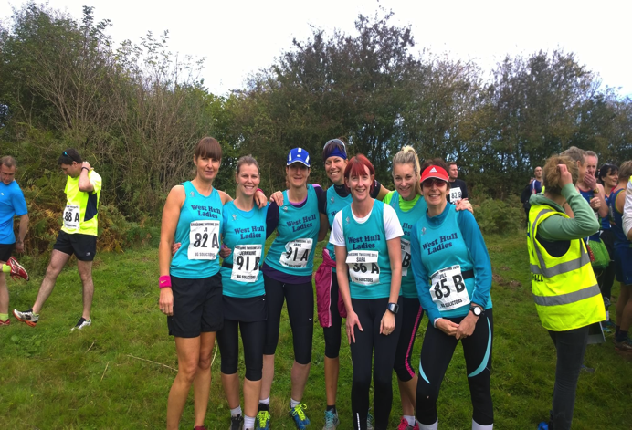
Gruesome Twosome Half Marathon 11th October

• Jo & Dale 1hr 56mins
• Sara & Rach 2hrs 16 mins
• Lynne & Jill 2hrs 24 mins
- Jane & Jermain 2hrs 39mins
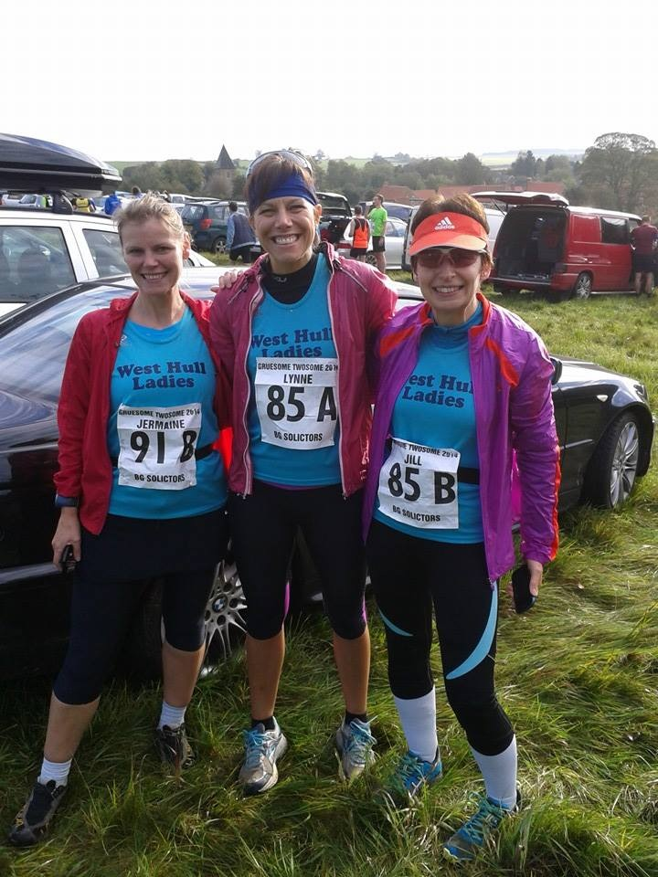

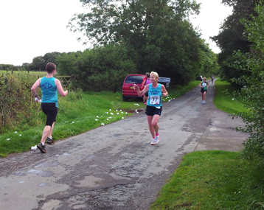
Major Stone Half Marathon 7th September

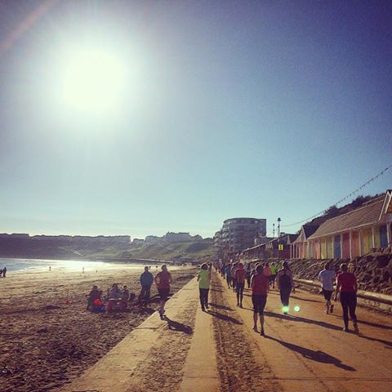
Scarborough 10K 12th October

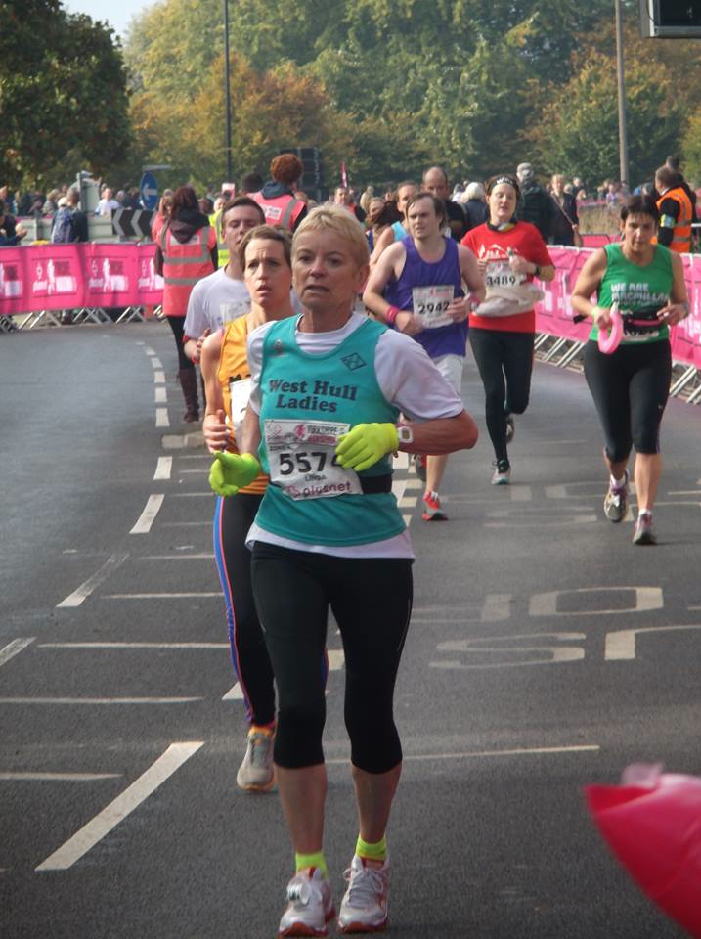
Yorkshire Marathon 12th October

Pos. | Finish time | Chip time | Participant | Cat | Speed | Pace
1 | 3:50:34 | 3:48:54 | Sandra Holdsworth | (F) V50 | 10.98 km/h | 5:27 min/km
2 | 4:08:56 | 4:02:12 | Linda Dodsworth | (F) V60 | 10.17 km/h | 5:53 min/km
3 | 4:20:58 | 4:17:03 | Laura Hogg | (F) SEN | 9.70 km/h | 6:11 min/km
4 | 4:25:05 | 4:21:09 | Ros Barbour | (F)OPEN | 9.55 km/h | 6:16 mn/k
1 | 4:33:19 | 4:29:23 | Jan Draper | (F) V50 | 9.26 km/h | 6:28 min/km
4 | 4:56:13 | 4:52:17 | Ann Holmes | (F) V40 | 8.55 km/h | 7:01 min/km
2 | 5:26:48 | 5:22:51 | Liz Draper | (F) SEN | 7.75 km/h | 7:44 min/km
5 | 5:49:26 | 5:42:39 | Karen Scott | (F) V40

West Hull Ladies

WEST HULL LADIES RRC COMMITTEE MEETING

Committee Meeting 6th October 2014

Minutes

Present Debbie, Rachael L, Jane, Karen Ann Linda, Zoe, Liz, Andrea, Maria, Hayley, Amanda, Sandra, Sally, Trish, Jill

- Apologies from Annette, Verity
- Minutes from Previous Meeting approved as accurate record
- Sandra said she would have more details about Club Membership fees nearer the time of the AGM. Jill had sent out the email to members about running when injured.
- Hayley spoke about whether ladies would be interested in attending a food seminar, which she could arrange. The lady who hosted these had a vast knowledge of nutrition and cooked on the premises where the seminar would be held. She would make it specific to running. The price would be about £20 each. It was expressed that this maybe a little high. Action - Hayley to send out email so member could express an interest or otherwise.
- Maria updated the Committee on the recent HAN meeting. It was reported that the area was in need of new officials for events - for example timekeepers, recorders. Action - Jill to put out email asking for any volunteers. Courses would be held to train any member wishing to do this.
- Amanda updated everyone about the proposed Hull Marathon. Please see resume

Feedback from the Hull Marathon Meeting (Phil Haskins and Adam Hardy)
Start/Finish area: Wilberforce Rd - Queens Garden. Sunday 13th September 2015 (Clash with GNR).
1. Cost (affiliated) £33 until 31st Dec, there after £35. Need 2,000 runners to be viable. 6 hour cut off.
2. Relay - 4 legs of approx 6.5 miles. The Relay changeovers will be well organised.
3. Route description -. Holderness Rd, East Park, back to town. Anlaby Rd, West Park, Boothferry Rd, Humber Bridge, Hessle Rd, Pickering Park, ASDA, Industrial area, Marina, Finish
4. Advertising. Website http://thehullmarathon.clever4.com Video of course to be made. Clubs, radio, Look North,
5. Launch 22nd October. Debbie, Hayley and Amanda to represent WHL.
6. Mile markers suggest sponsor by companies e.g. Mile 10 provided by Arco (which wil also advertise when businesses are approached)
7. 260 marshals needed just for East Park area ….
8. East Park - Family fun day. Friends of Pickering Park.
9. Water stations, relay change overs, first aid ….
10. Volunteer bands wanted
11. Course measure to be carried out late October.
Next Meeting 25th November, Hull Sport

Although problems with the original Hull Marathon, WHL had a good day with 6 ladies running the marathon, two relay teams, manning the West Park water station with our WHL logo out on display. We hope this to be a high profile event again for West Hull Ladies, this time one to make us proud of Hull.

- 2 ladies had gained places in the London Marathon ballot, 2 had good for age entries and 1 a deferred entry. Therefore 5 ladies were eligible to be in the ballot for the 2 available Club Places. A discussion then took place about the selection criteria for being allowed into the ballot. It was agreed that this could not be changed at the present time but could be looked at and if needed amendments could be brought to the AGM for them to be changed.
- Debbie informed the group of the YVAA Cross Country that would be taking place later this month. We did not have enough ladies for the different age categories.
- Debbie informed the group of a coaching conference that was due to take place at Hull University on the 9th December at a cost of £15. It was not decided at this time whether members who attended would be subsidised by the Club.
- Debbie updated that all the forms had now been signed and were with the bank and progress was being made.
- Sally who was stepping down from the role of Member Secretary was thanked for her excellent work. Karen Scott agreed to take over the role for which the committee were very grateful. Sally would ensure that the London Marathon Club places were sorted prior to handing over the full reins to Karen.
- Heidi Bradley introduced herself as the Club and Coach Support Officer for the Humberside region. She advised us that she was arranging workshops in the local area and wanted to know what we would be interested in. The workshops would take place at the Club. She agreed that she would email a list of what workshops had been held before and then we could progress it. Heidi also asked that we have a system whereby new ladies could register with Run England. Action Amanda to scan in the membership form and place on the Club web site. This has now been done and Ann has registered the Club on the Run England web site. Heidi also stated that there was bursaries available for anyone interested in the course - Coaching in Running Fitness.
- A discussion took place about track sessions at Costello. There is a cost implication but the more ladies attend the cheaper it will be. Action Debbie to send out email and together with Sara hold monthly track sessions.
- Amanda updated the members about the track championships races that we had been invited to attend by City of Hull Athletic Club. The races had consisted of a mile race, 3km and the last race to be held on 8th October 5km.
- AOB. Amanda spoke about the running of another beginners course in the New Year. The below is a list that needs consideration and discussing at the next meeting

6W-5K course is put on the agenda for the November Meeting and to discuss:
• Shall we run it?
• When? 5th January allows 6 weeks to complete before half term.
• Can we get 2 leaders per session to volunteer? (I will try to do all Mondays to include a 10 min coaching talk before we start)
• Can we get at least 2 buddies per session?
• Payment in 2 parts? £20 for 4 weeks, £10 to complete. All completers will get social membership to 31st March then full membershipt to 31st March 2016.
• Advertising? Website, Run England, people's work places…..

Also discussed was the 10k series. Annette did an excellent job but ladies were now to email the Club with details of 10ks that they had completed together with a link of possible to the results. Action Amanda to send email explaining changes to members.

Hi Menopause Mates (Pre, During and Post),

Menopause Mayhem by Amanda

I have made it to the big M at the age of 55. I was not looking forward to it seeing what it was doing to others and suspecting at the back of my mind that biologically women are around to reproduce and it might not be whippy dee when that option is no longer possible!

I like to know what is going on so started researching and some of what I have learned is changing my diet/exercise regime. You may have checked it all out but, if not, I hope this is useful and enables you to protect yourself as it’s not pretty!
The main factor of menopause is the reduction of the hormone oestrogen. This causes periods to stop but it also has other effects. Oestrogen receptors are in the vagina, uterus, ovary, bladder, skin, bone, heart, blood vessels and breasts. When oestrogen levels become low these tissues become inactive. Oestrogen also affects the brain chemicals (hot flushes).

The most common symptoms of menopause are: hot flushes, night sweats, sleep disturbances, vaginal dryness, urinary incontinence, mood swings (possibly depression), weight gain, heart disease, increased risk of stroke and osteoporosis.
Of the above there were three that stood out immediately to me as being very significant:

Heart disease (and stroke): Following menopause your risk of heart disease is 2-3 times greater than before (on a par with men now). This is partly due to the heart no longer being protected by oestrogen but more significantly the blood vessels are no longer able to protect against an increase in cholesterol. Around menopause cholesterol in women increases significantly.
What to do? You already know this: eat well, exercise, watch your weight, don’t smoke, steady on the alcohol, sleep enough, avoid stress.

Osteoporosis: Your peak bone density occurs around the age of 30 years after which bone density decreases gradually until menopause when reduction increases massively up to 2% per year for the first 5 years and thereafter 1-1.5% resulting in up to a 30% loss by 80 years. This is much worse than I expected. I was glibly assuming that as a runner I would be fine. However, no matter what I do it will decrease, I can only change the rate it decreases.

What is happening? The lack of oestrogen results in inhibition of bone formation. Bones constantly break down and rebuild but the balance now means more bone is being removed from the skeleton than built. Bones need adequate calcium and vitamin D however, your ability to absorb calcium in the gut also decreases during menopause and our older skin makes it harder to produce vitamin D from the sun.
What to do?
- Eat lots of calcium and ensure you get enough vitamin D (sunshine).
Note: It is recommended on the days you spend indoors, on dull/rainy days, on sunny days when you are wrapped up because it is cold and even on sunny says when you wear suntan cream that you take vitamin D supplement i.e. almost every day.
- Take up an impact sport like running, skipping or circuit type training (which includes jumping, burpees, star jumps etc.) or horse riding.
- Weight lift/strength train. This is done with the biggest weights you can manage but for a short number of repetitions. Heavy enough for your muscles to be ‘pulling on the bones’.
For me menopause came sudden and acted like a switch. It is now 7 months since my final period and I cannot imagine having one again though, as advised by mates, I try to remember to carry protection. I suddenly could not run as fast and quickly had to reduce my pace. I had niggles and aches, my body did not feel like mine.
I read regarding running: ‘some women experience slower pace, increased aches, prolonged recovery and declining energy’ which was spot on for me and my running got slower and slower. But I also read: ‘the good news is that many runners report that performance effects during the menopause transition often resolve when menopause completes’ which gives me plenty of optimism and I am already improving. My body feels like mine again and I am enjoying running once more … though I may never be quite as fast again, we shall see.
In all other ways I seem to be sailing through the other symptoms such as mood swings (as recommended I am taking vitamin B6), no disturbed nights or weight gain and the hot flushes are quite amusing so I am obviously having it easy.

Foot note: Much of the information above was summarised from the ‘Running for Women’ book by Jason R. Karp and Carolyn S. Smith and backed up by various searches on the internet plus a documentary on TV.

Isle of Axholme Half Marathon – Linda
28th September 2014

I entered this race only because I need that last long run before the York Marathon. There wasn’t any other ladies from our club entering but I know Epworth well and wanted to enjoy a nice run round the countryside.

Arrived in plenty of time to get my number and have the many wee’s we all need before a race! Lovely to meet up with Penny from East Hull Harriers, the only other runner from Hull. Got chatting before the start and realised that she knows Jan, small world.

I decided to ‘test’ out what I would be wearing on the big day and had on a short sleeve t-shirt under my WHL vest, as the gun went off at the start the sun came out, it had been cloudy and quite cool up to this point. Off we went to lots of cheers from the spectators, the route kind of goes round and back again to the start before it gets underway along the country roads. There were some uphills but not many and they were not steep but there were plenty of downhills, in fact a lot more down than up. Then for many miles it was just flat. I had done quite a good pace until mile 9 where I was so hot I decided that I just had to try and take off my t-shirt which was under my vest. Trying to work out how I was going to do that it wasn’t until mile 10 that I just had to so I wiggled out of my vest and then took off the t-shirt much to the amusement of the chaps behind who wondered and even asked if I was doing a strip-tease!! So managed to strip down to bra and then try and put vest back on which was sweaty and I got all tangled up so I had to walk while I sorted out my attire and made myself comfortable. So now I had this wet, soggy t-shirt to carry because it wouldn’t tie up round my waist, oh well I now have a big soggy thing to wipe my face on. All that faffing about cost me many minutes and made me lose my way a bit, in fact a lot, but I consoled myself with the fact that this wasn’t actually a race it was a training run so come on Linda head down and get on with it, not many miles left now.

Finally the end was in sight, only 200 metres left into the market square. Not my best time but I had on my watch 2hrs 26secs. Penny from East Hull Harriers came in behind me and we both found a bench and sat down while we commiserated our times but on getting back to the car I saw the temperature was 75F (in old money) on checking on the internet I think that is 24C no wonder we were all washed out.

Got a lovely pink t’shirt at the finish so all that hard work was worth it, you are all going to be so jealous when I come to the club in it! Although the guys didn’t look too good in the pink colour!
Yorkshire Marathon

YORK MARATHON - Linda

I decided a long time ago I would run a marathon when I was 60 years old. Finally as I approached my 59th birthday I thought I’d better get my finger out and start training. I hadn’t ran since I was in my 30’s!

I started out just running a mile and progressed until I entered my first 10k in Hull and that’s when I saw WHL, I decided that I needed direction and joined. This has been the best thing I have ever done because I certainly would not have been on the start line without this club.

So after various training sessions and events, from 10k to Champagne League, Rudolph Romp, Golden Fleece and even the Thunder Run I finally felt I was prepared for this event. I have only been with the club since June 2013 and I have improved so much due to all the encouragement, training and advice from everyone.

After a very long week Sunday morning finally arrived, the weather was awful I have never seen such thick fog and I had to drive from South Cave to Elvington with my trusty passengers Jan and Liz and a big thank you to Liz for keeping me on the right side of the road! We finally arrived at the air field in Elvington and caught the Park and Run bus to the University, gosh it was cold and I must admit I was shivering uncontrollably but I think it was more to do with nerves than anything else! We met up with some of our other lovely ladies, Ann, Ros and Laura and had a nice chat, catch up and laugh whilst waiting to walk to the start area. We then caught up with Karen. After a couple of loo stops we were on our way to the start. Having never done an event like this before I really didn’t know what to expect. Karen and I were together in zone 4, the other ladies were in zone 3 and Sandra (who we hadn’t seen) was in zone 2. Karen and I finally got over the start line after 7 mins. Then we were off.

I had visited Sandra earlier in the week and she gave me such a lot of advice so I was ready to keep my eye on my watch so I didn’t go off too fast. I often make this mistake and burn out three miles before the end of any race! I got myself into a nice rhythm and away we went. We hadn’t been running long before I heard lots of encouraging shouts from our lovely Sharon Wiley, this made me a bit emotional. The support from all the spectators during the race was fantastic. There are a couple of places in the race where you see the faster runners coming back running towards you, I don’t usually like that in a race but it was lovely to see Sandra who cheered me on. I also got a lovely high five and cheer from Rich of City of Hull which was fantastic. Then when I made the turn I was able to see our lovely ladies running towards me, Ann, Laura, Ros, Jan and Liz but I didn’t see Karen.

I had a bit of a wobble between mile 18/19 and just felt I couldn’t go on any more. I had to stop and get myself a gel out of my pouch, that was not an easy task, why is everything so hard when you’re tired and cold? Then I couldn’t get the top off but finally managed after squirting myself all over my arms with gel gunk! The water station was close by too so I decided to walk to it while taking my gel and then having a lovely long drink of water. At this point I had to really give myself a good talking to, ‘I can do this, there aren’t that many miles left, dig deep and get on with it’, with the image of Rachael Laughton running along beside me and the image of all the boxer dogs I was helping by raising money for Boxer Rescue, off I went. My quads hurt like hell and my toes kept cramping up but finally I was at the hill that Sandra had told me about, this was a mile from the finish and seemed to go on forever, I literally dragged myself up it and then it was a lovely downhill finish to the finish line. As I approached the finish I could hear them say my name and West Hull Ladies and that this was my very first marathon at the ripe old age of 60! I got through the finish and stopped and couldn’t help but cry and sob while I started what seemed like a long walk to finish area for my well deserved goodie bag and tee shirt. This is where I finally caught up with the lovely Sandra who had done an amazing time, we had a big WHL hug and a cry together. My finish time was 4hrs 2mins 12secs (chip) I am absolutely over the moon with that as it gives me good for age so now I can enter the 2016 London Marathon if I really want to put myself though that!!!

I would like to say a huge thank you to Sharon Wiley, Jill Jameson and Zoe Jameson for the cheering, support and photo taking during this event, you are amazing and I really needed the encouragement, and a special thank you to my fellow runners, Sandra, Ann, Jan, Liz, Ros, Laura and Karen who were all fabulous. Another thank you to everyone in the club who has trained with me and got me to this point. You are all awesome.

York Marathon - Sandra

Up at 5.50am - wash, put on West Hull Ladies uniform, go downstairs, eat porridge, drink a cup of coffee, and make a flask of green tea for the journey. Remember to swig a Beet it Shot - grab a banana - sneak out the back door into the fog and mist. Get into the car and slowly make my way to Elvington airfield. After that start to the morning you would think running the Marathon would be easy!

Into the pen - I was in Zone 2 and felt a bit of a fraud - frightened that they would be off too fast for me. Whilst waiting for the start became a little concerned as my toes on both feet were cramping - not good.

Matt Dawson was the starter and at 9.30 we were off into the fog and mist. After about 400-800metres I heard some one shouting ‘Come on West Hull Ladies’. It was so unexpected - it was Sharron and it made me cry with emotion. How blooming fantastic that she and her family turned out in such appalling conditions to cheer us on - still brings a lump to my throat when I think about it. What a wonderful club member.

Looked at my watch - going to fast but think - it feels quite easy just go. Felt a little like a top class athlete - running alongside the motorbike that was doing the filming. Really could have done without that but there was nowhere for it to go.

Past the Cathedral and the peeling bells - out into the countryside. Saw the Vicar and some of his congregation outside a church - went over to high 5 him - hoping that if I needed Gods help later this would hold me in good stead.

Saw the pipe band who only started playing after I had gone past. At the halfway mark still feeling good but remembering this was how it was last year.

Turned to go towards Stamford Bridge - heard the family cheering me - stop for a hug and a kiss from each of them. Go a little further along - heard Jill and saw Zoe (sorry Jill had to say that!!). Again unexpected support - fabulous - realised sunglasses were just added weight to carry and threw them at Jill.

Along the A64 - wasn’t as bad this year as I was ready for it. Loved seeing other local club runners. Saw Rich Harrison - another high 5. Turned to make my way back, saw Linda - looking fabulous - saw Tony Audenshaw from Emmerdale - what was he doing behind me???
Laura and Ros - they were also looking great.

At the 20-mile mark - stopped for a gel - leg cramping - heel drops on kerb. Don’t stop as it makes it worse. Keep going only 10k to do. Ha ha.

Time dropping but still just over 9 min mile pace so no panic although know it is soon going to be painful.

Legs not feeling good - took sachet of salt that I had in my bag. Got my last bottle of water. Grasped it like a dummy. I so needed it to drink and pour over myself.

2 miles to go - it is so hard to keep going.
Tony Audenshaw flew past.
Supporters have been fantastic all the way but even more so now. They can see how hard this is so seem to give individual support - so pleased for that.

See the hill coming and unlike last year I was so pleased to see it, as I knew I was nearly home. Up the hill and then down - sprint (?) to the finish line.

And its over.. ….. Gosh that was fun - can’t wait for next year.

Had a really bad cramp attack at the finish and when got home realised why I had trouble with my feet. The night before I had taped them to help provide support - I think it was on too tight - won’t do that again.

Thanks to Sharron, Zoe, and Jill - your support really really helped.

Scarborough 10K - Diane

I really enjoyed the whole experience of my first Scarborough 10k. Andrea, Rosie and Anna travelled with me which was really nice as it would have been a long boring journey otherwise! The fog which kept appearing in various places wasn't so good and it was really cold when we arrived at the park and ride but at the seafront it was sunny and clear. The pre race was very well organised and we saw Marie and Vicky at the start. We set off down the seafront around the castle up to the sea life centre and made our way back. Some parts were cobbles which I didn't like (as I'm prone to cockling) and there were some gentle up hills which I wasn't expecting but it made up for it with the down slopes. The crowds were really encouraging and it's always great to hear 'come on West Hull Ladies', by the time we were heading back the sun was really warm which made it harder but one by one all the West Hull Ladies were over the finish line and rewarded with bananas and water. Was good to see Bev finishing too after her first 10k this year following her injuries. I'm really pleased to have again beat my previous time - my chip time was 57:46.

Displaying our new orange t-shirts we refuelled with fish and chips while sat on the beach in the glorious weather where I could have stayed a lot longer had I not needed a shower, at this point we realised that the WHL Yorkshire marathon runners would STILL be running. It was definitely worth the journey there and the lovely weather did help, I don't know about the others but I'd like to do it again next year. Well done to all the other WHL who ran this weekend at various events.

Scarborough 10K - Anna

Well- you all know how I love to get sand in my trainers- well Scarborough delivered!!
This was my third attempt at getting to do the Yorkshire Coast 10K- first year I was ill, then next I missed out on a place. So I was delighted to finally get a go.
Our journey was a complete mix of British weather- all in a couple of hours. The fog was thick on the drive there, and we froze waiting for the park and ride bus.
These are moments when you start to doubt all your fashion choices for the day- too many clothes/ not enough clothes/ long sleeves/ short sleeves etc- who knows. We had faith in the weather forecast though, and I am glad that we did, because we then arrived at The Spa it was basking in glorious sunshine. Scarborough, as ever, looked superb. There was still a sea mist sitting on the tops of the cliffs- really atmospheric.

We set off along the sea front, and the route was just as I had imagined- round South Bay, then North Bay and back. The view was really distracting- such a beautiful run with plenty to look at. The only sad bit was seeing the old outdoor pool that I had played in as a child looking really quite sad and run down. But we soon headed off past Peasholme park, and on to the Sealife centre.
One benefit of a route that goes up, turnaround and back, is that you get to see your friends running past. These points were a boost, and Rosie and I even had the strength for a high 5!
I enjoyed the run. and felt really comfortable. I wasn't that impressed with my time, but the fact that I had felt strong and relaxed through the run was a result enough for me.
Diane had stocked up with water for us all at the finish, so it was even more of a delight to see her! We all gathered up at the finish, and then went off for some chips on the beach. Bliss. Lots of other runners had the same idea- there was a sea of orange t-shirts along the seafront- looked great!

This is such a well organised event. Everything was easy and no hassle- from leaving bags, to loos, to lining up- no stress. The route is fabulous- flat and wide, with a little bit of sand for me, and the setting is just great. Its a really good first ten K race if that's what anyone is looking for.

There was a lovely team of West Hull Ladies at this event- Diane, Andrea, Rosie, Marie, Vicki and Bev- who Im sorry Bev- we didn't see you until running. We were all thinking of the girls in York- and made sure that we didn't moan too much about a mere 6 miles when we knew how much effort that they would be putting in. And we were happily scoffing our fish and chips whilst they were still running despite starting before us! We did think of you!

Thank you so much Di for getting us there and back, and to our group for getting rid of my nerves at the start, and making it such a fun day out. As ever, I had a great day- cheers!.
We ought to put that on our website- great support and lovely company guaranteed or your money back! Because I get that every time from the West Hull Ladies:)

June first 2015- online entries start for next year- I'm in!

Birmingham Canal Canter – Ann

Birmingham Canal Canter 13th September

I couldn’t resist this one - its organised by the Long Distance Walking Association (i.e. think Rudolph Romp and Golden Fleece without the mud and the hills). These events, in my experience are great value for money, with absolutely no pressure about completion time and nice food.

This event met my expectations to a tee.

HQ was an activity centre in the centre of Birmingham with accommodation, so for £15 we got a proper bed, pizzas, teas and coffees the evening before, and then plenty of food for breakfast on the morning - porridge (in packets, but it was bearable), toast (the nutty brown stuff) as well as a full cooked breakfast (I got offered this after I’d filled up on porridge and toast!!).

The walkers set off at 8.30 and the runners left an hour later - this was to prevent runners arriving at the checkpoints too early. We all had a very comprehensive set of directions, but there were also signs around and the odd red and white tape hanging from trees as well. This is much more than you’d get with some LDWA events, and ideal for the directionally challenged, such as myself. Even so, we all set off and instead of reading the instructions, I just followed everyone else. This worked for a few minutes, but it wasn’t long before the field thinned out and the runner in front turned a corner and vanished. Fortunately we were still running on roads at this point, so it was easy to work out where I was.

Just one and a half miles in I took a tumble, but no harm done, so I dusted myself off and carried on. I soon felt a bit isolated, so was pleased that I met up with a chap, Andy, who had done the event two or three times before. He warned me not to rely on him for directions, but of course I did, well at first, anyway.

It wasn’t long before we went wrong, but we only made a couple of minor errors, and soon corrected our mistakes. There was an 18 and a 26 mile route, and we’d taken the wrong route. We decided at that point to read the directions more carefully, and not blindly follow whoever was in front. This meant taking our time to check the directions frequently with the odd walk here and there, which was fine by me.

For those who did Golden Fleece - it wasn’t like this, where you had to have studied the map really well to know where to go. I didn’t take a map, and the directions were very accurate, but you did have to take your time to check. Apparently last year a female runner from Poland was found by a kayak club 7 miles off route, and they rang the race director to find out where she should be, then put her in a two-man kayak and paddled her back to the right place!!

There were four checkpoints, about 6 miles apart. The first one was at a pub, and had toast, and teas and coffees, and cold drinks. It was nice to be able to use the loo as well. I thought I’d lost my buddy, but within a few minutes of setting off again we met up and carried on. The two ladies in pink - chatty, chatty, passed us.

Running along canals in Birmingham was mostly very lovely indeed - quiet, peaceful, natural. It was wonderful being in the heart of Britain’s second major city and have such a peaceful run - for the whole 26 miles! At one section we were running between a canal and the rail line that goes from my home town to Birmingham - if someone had told me as a 10 year old that one day that canal I could see from the window of my train would be part of my marathon route …

Checkpoint two had sandwiches and drinks - proper sandwiches, with tomato and cucumber and ham in! We didn’t stop long because we were both still feeling pretty fresh, and the next stop was cake. We kept catching up with pink ladies, but also the two younger fitter ones. We’d caught up with a seemingly faster group of runners (how do we make these assumptions?) and decided that they’d all followed one another the wrong way and were now behind schedule.

By this stage we were overtaking the walkers who’d had the head start. This was good - with plenty of slower people behind us, our placings in the top half of the field were secure. After this the route took us through Canon Hill Park - this was so beautiful - the flower beds were just stunning. I’d love to do Parkrun here one day.

Checkpoint three was only on the 26 mile route, on an extra loop that went right through the city centre. This was a bit bizarre, as the canal paths were populated with shoppers and eaters at the bars and tea rooms along this very pretty section. A few bridges later and we were out onto peaceful territory again, with the checkpoint soon appearing - this was a delightful spot for cake. In fact it was a cake competition - there were about 8 different types of cake, and my running partner tried nearly all of them before giving his verdict on the chocolate cake, although I voted for the shortbread.

We slowed our pace a little after this, partly to digest the cake and partly to lose a guy who talked too much, but mumbled as well, so you couldn’t work out what he was saying anyway. He started to pull away, but when we got back to the busy section where the shoppers were, we noticed that he hadn’t consulted his directions, and was re-tracing his steps too much. He’d have ended up back at the start! Amazingly, my new pal had a whistle - he blew it to attract his attention, but he couldn’t hear it - heaven knows how far he’d have run before realising he’d gone wrong.

The next section took us to spaghetti junction - who knew that there is a spaghetti of canal and river junctions here as well?! This really was a hidden Birmingham being revealed at every turn. There were a lot of locks at this section - which involved a bit of climbing, but they were just short bursts, which we walked. It amazed me how slow the canal boats moved - we were much faster. I decided that I would never want to go on a canal boat holiday - far too slow for my liking, and getting through those locks must’ve taken all afternoon.

As we headed toward the final checkpoint, we spotted the pink ladies in in the distance, and my pal wondered whether we’d be able to catch them. That was all the invitation I needed, so I upped the pace, ran in front, and yes, we caught them up … and then the two young fitter ones as well. We raced through the last checkpoint to maintain our lead (did I say there were no time pressures on this event?!!), and I decided to up the pace even further and see if Andy could keep up. The conversation stopped, but he stayed with me, and was delighted to have finished within one minute of his previous two years!!

So in summary, my £12 entry fee paid for -
tea / coffee at the start
tea / coffee / squash / toast with marmalade at CP1
squash / sandwiches / pineapple at CP2
squash, chocolate cake, brownies, shortbread, ginger cake, chelsea bun, sun cream and bite cream at CP3
squash, peanuts, Jaffa cakes, carrot cake at CP4
Pepsi, squash, tea, coffee, baked potato with beans and cheese at the end
showers and car park.

oh and a certificate
I’d call that a good day out!

Park Run
WHL – v - Sunday Girls Challenge 20th September 2014 at East Park

The results from the parkrun challenge between West Hull Ladies and the Sunday Girls Road Club are below.

Sunday Girls
Flora MARRIOTT 23:20 VW45-49 68.71%
Suzanne SZENHER 25:04:00 VW50-54 66.89%
June HERON 27:26:00 VW50-54 61.85%

Average 65.82%

West Hull Ladies
Ann HOLMES 23:55 VW45-49 67.04%
Linda DODSWORTH 25:30:00 VW60-64 75.03%
Rachel ANDERSON 25:43:00 VW35-39 58.33%
Elizabeth DRAPER 27:10:00 SW25-29 54.48%
Diane PICKERING 28:33:00 VW40-44 54.70%
Sharon HARTLEY 28:40:00 VW60-64 69.65%
Megan BEADLE 30:32:00 SW25-29 48.47%
Suzanne CLARKSON 33:45:00 VW55-59 55.90%

Average 60.45%

Sadly for WHL the Sunday Girls won by highest average age grading, but the competition was obviously worthwhile as 3 of our ladies achieved pbs - Linda, Rachel and Diane - and Linda and Rachel were both first in their age categories. I think we can award ourselves the victory!

Fantastic running from everyone and well done for taking part.

The return leg is on Saturday 15th November at 2pm at Skidby Mill

10 mile cycle time trial - who's game?
(Remember this is a bit of fun, and they've already beat us once anyway!!)

6W – 5K Ladies

It’s time to get registered for Hull Parkrun. It is very straight forward, click on this link and follow the instructions: http://www.parkrun.org.uk/register PLEASE NOTE. If you plan to join the club put your club down as West Hull Ladies. You are then emailed your barcode which you print off and take with you to your first parkrun. You need the barcode for the timing.

What is the parkrun? It’s a free event, run by volunteers. It is a measured 5K distance, timed and recorded. All kinds of people run or walk the event. It is very friendly.
Find out more http://www.parkrun.org.uk/hull Click on the Results tab and you will get an idea of the times people do plus category positions and age grading.

There are 3 parkruns in Hull but the best one for you to try first is East Park as it is all run on tarmac and there are a large number of runners.

The 6 weeks to 5K completes on Friday 24th October and the first parkrun would be Saturday 25th October however, I have heard that one of the new ones cannot make it that date.
Please reply to let us know if you can run on Saturday 26th October or Saturday 1st November or both (hopefully both), the intention is to encourage as many West Hull Ladies out for your first event.

Recipes & Nutrition

Date Apricot and Walnut Flapjacks - Sandra

Make a batch of these to munch on during the few days before an event.

Prep time 5-10 mins
Cook Time 15-20 mins

20cm square shallow tin - greased and lined with greaseproof paper.

Ingredients
75g butter
2 tbls golden syrup
1 tbsp soft light brown sugar
75g walnut pieces
75g mix of dried apricots/dates chopped
zest of half a lemon.
200g whole rolled oats

Makes 12 bars

- Preheat oven to 170C/gas mark 3
- Melt the butter/sugar /syrup on low heat in a saucepan. When sugar has dissolved add the rest of the ingredients. If mixture seems sloppy add another handful of oats.
- Turn the mixture into tin and press down with the back of a spoon,
- Bake in oven for 15-20 mins until golden.
- Leave to cool slightly then mark into fingers or squares with really sharp knife.
- When cool remove from tin and eat!

Zesty Lemon Curd Crunch Bars - Sandra

Tangy, moist and packed with carbohydrate to sustain you through your race.

Prep time 5-10 mins
Cook time 20 mins

20cm square shallow cake tin greased and lined.

Ingredients

80g butter
1 tbsp soft light brown sugar
2tbls lemon curd
2 tbls golden syrup
Grated zest of a lemon
Squeeze of lemon juice
250g rolled oats

- Preheat oven to 175C
- Melt the butter with the sugar on a low heat in a saucepan. When sugar has dissolved add the lemon curd and golden syrup
- Add the lemon zest and a squeeze of lemon juice and stir to combine
- Stir in the porridge oats and mix together well. Leave to stand for 10 mins
- Turn the mixture into the tin and level with back of spoon
- Bake in the oven for 20 mins. Remove from oven
- Leave to cool slightly and mark into fingers or squares with really sharp knife.
- Remove from tin when cool.

I only had 23cm tins so I did one and half times the amount. It doesn’t look quite cooked when you take out the oven but it does firm up.

Breakfast Smoothie - Linda

The colder weather is on its way, time for us to try and scare off those cold and flu bugs. This is my recipe which I drink every day and it works for me.

400ml Milk
250g Greek Yoghurt
40g Wheatgerm or Oatmeal
240g frozen fruit (I love Mango but you can use any fruit)
A good piece of fresh Ginger
3 dessert spoons of runny honey
50g Almonds

Whizz in your blender and pour into glasses, this quantity usually makes 5 small glasses. Leave in the fridge and drink each morning along with your breakfast.

Workshop in Nutrition and Weight Management for Female Runners Mark Harrison

12th November, 7pm, Hull Sports, Old Ackroyd Room
- What does 'losing weight' really mean? - Fundamentals of losing/gaining weight... - How to do this in a healthy way... - How exercise can improve this... - How to measure body composition - Recipes (Including samples) - Q & A session
* All attendees will receive an email with recipes from the session and a body composition tracker for their use. This will be an interactive than the last one, with parts getting you guys involved with a few areas.

The cost would only be £5 per person, which will include samples of some recipes and the follow up email with some useable resources on there.
There would have to be a minimum of 10 people attending, but there is no upper limit as the session can incorporate everyone

Workshop in Breathing and Posture Jamie Barrington, BodyFixed

29th October, 7pm. Hull Sports (YPI), Hull FC video suite (Next to Latus strength and conditioning studio).

The format will consist of a 30 minute presentation explaining the importance of breathing and elements of posture, from his prespective, followed by a 15-30 minute practical session. The aim is to give you an understanding of the respiratory system and the effect it has on injury reduction and increasing performance.

Charities & Fundraising

Hayley is hosting an Evening of FUNdraising on 14th November at the Three Tuns Pub, Boothferry Road, Hull. The evening includes a sports auction, raffle, rock n roll bingo, karaoke and a charity head shave. All monies raised are for her Iceland Trek Challenge (23-30th May 2015) in support of Dove House Hospice. It would be lovely to see some WHL there!

https://iceland.everydayhero.com/uk/hayley-jackson

Racing and Running Events
Fancy something different? For worldwide marathons click here

Date/Time | Event | Fee | Entry forms | Online entry
September 2014
26th/11:00 | Haltemprice 10K | £7 UKA/£9 | Entry form | Postal entries only
November 2014
2nd/10:30 | Guy Fawkes 10 Mile | £12 UKA/£14 | Online entries only | online entry
2nd/11:00 | Deepdale Dash 10K | £12 UKA/£14 | Online entries only | online entry
9th/11:00 | Dalby Dash 10K | £11 UKA/£13 | Online entries only | online entry
16th/09:30 | Leeds Abbey Dash 10K | £18 UKA/£20 | Online entries only | online entry
December 2014
6th/08:30 | Rudolph's Romp | £10 | Entry form | Postal entries only

Please remember to double check dates, times and entry fees with the official website or the entry form.

www.westhullladies.org.uk/races.htm Zoe, Racing Officer

NOTE: Club Vests must be worn at any races you enter
under the West Hull Ladies running club name.

West Hull Ladies Road Running Club
Kit Order Form

FORENAME ___________________________________

SURNAME ___________________________________

ORDER - tick what you require, with size Price

- VEST SIZE ___________ £16.00
- LONG SLEEVE TOP SIZE ___________ £18.50
- BEANIE HAT £6.50
DATE Ordered _______________

AMOUNT PAID _______________

Please transfer payments online with your name and marked as ‘Kit’ to:
Account: 63762742 Sort Code: 20 43 49.
Or cheque payable to ‘West Hull Ladies RRC’, and write your name and ‘Kit’ on the back and give to Club Treasurer Debbie Watson, 51 Westbourne Ave, Hull.

Sign on receipt of goods _________________________________

DATE _______________

Please complete this form and email to diazmaria@btinternet.com

Thanks.
Maria
Kit Officer

